GITHUB COMMANDS

Added some files to staging area that should NOT be there

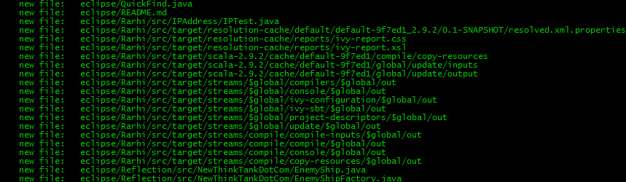

I want to remove the ‘Rarhi’ folder completely. So I do this:

$ git rm -r --cached **/Rarhi

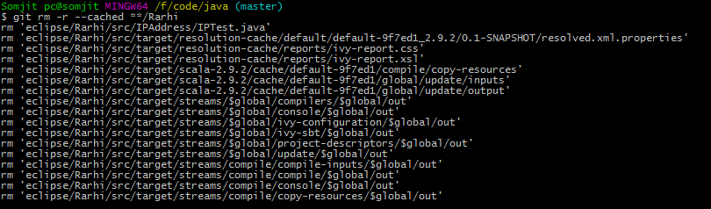

Here’s what each of the flags do

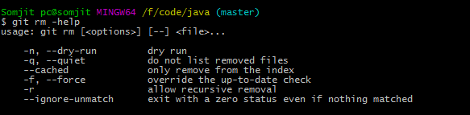

The ‘**’ is telling git to search for stuff in zero or more subdirectories. Available from git 1.8

ADDING one instance of an otherwise blocked filetype:

My .gitignore says to block .docx files, but I want this file to go through. So I modify the .gitignore file as such (notice the ! at start, meaning ‘not’ ignore) : !GIT Commands.docx

And then doing a *grep* over a git status like so shows the file as added (after I did a git add <folder>)



After commiting changes, here’s what git log shows :

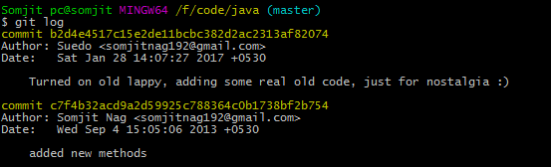

It’s been 3 years since the last commit! Back then, these small codes were my practice partners. Nostalgic stuff! ☺

NB: I’m gonna move this from the /eclipse subfolder out into the parent(one cd.. that is), so, in future the path of this document is probably not gonna be the same as in these screenshots.

Update: Moved the file, and here’s what was needed on the git bash side of things:

1. Saved this file in the parent Java folder
2. Git add-ed /eclipse and this file  
     
     
   
3. Git status showed this now:  
   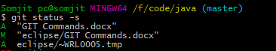  
     
   The new file ‘A’ as added in the parent folder, and the original one inside /eclipse folder as ‘M’ for modified, as I was typing here.
4. Now just removed the one staged inside the /eclipse folder, and here’s what git status shows now:  
     
   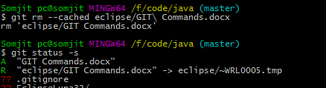  
     
   ‘R’ as in removed. Note, this is just from the staged area. It does not delete the copy of the file in my hard drive. **I need to remove this, else next ‘git add’ onwards, it will again be added.**
5. Commited,and here’s what git log says :  
   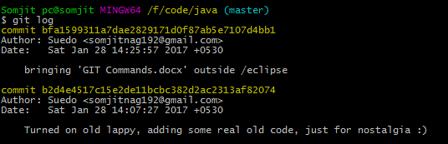

The view out there in github.com land:

